**SIT Result – Environment UAT API External**

## Result Summary SIT External

UAT External Error Result:

- 401 Unauthorized:

- Authentication -> Retry OTP

- Authentication -> Retry OTP Encryption

- 404 Not Found:

- Product Creation -> BIFast -> Alias Registration Inquiry

- Product Creation -> BIFast -> Alias Management Request

- Product Creation -> Virtual Account -> Delete Virtual Account

- Financial Information -> Virtual Account -> Inquiry Status Virtual Account

- 500 Internal Server Error:

- Financial Information -> CASA -> Inquiry Balance VID with OTP

- Financial Transaction -> Umrah -> Umrah Payment Insurance

- Financial Transaction -> Umrah -> Umrah Payment PPIU

- Financial Transaction -> Online Credit Card -> Credit Card Installment

- Financial Transaction -> CASA -> Direct Debit E-Commerce Payment

- Product Creation -> CASA -> RTGS Request

- Product Creation -> CASA -> SKN Request

- Product Creation -> CASA -> Direct Debit E-Commerce Unregistration

- Product Creation -> Virtual Account -> Registration of VA & Bill

- Financial Information -> BIFast -> Account Enquiry

- Financial Information -> Umrah -> Umrah Information Transaction List

- Financial Information -> Umrah -> Umrah Inquiry Payment

- Financial Information -> Umrah -> Umrah Print Transaction

## Result Summary SIT Internal

UAT Internal SIT Result:  
- 400 Bad Request:  
  - Dcash -> Predator Fraud  
  - NGI -> Customer Inquiry Detail  
  - NGI -> Customer Inquiry  
  - NGI -> Account Inquiry Loan  
  - Middleware -> QR Cross Border Payment  
  - Transaction -> Overbooking CASA (EFTON)  
  - Transaction -> Sismontavar  
  - Inquiry -> Customer Inquiry  
  - Inquiry -> Customer Inquiry Detail    
- 400 Invalid Service Code:  
  - Middleware -> QR Cross Border Inquiry  
  - Middleware -> QR Cross Border Check Status  
- 401 Unauthorized:  
  - Dcash -> Reversal Overbooking CASA GL  
  - NGI -> Account Inquiry Loan  
  - RPA -> Account Inquiry  
  - RPA -> Payment Status  
  - JPM -> Payment Status  
  - Transaction -> Cancel Deal  
  - Transaction -> BDS Transaction  
  - Customer -> Send Result  
  - Customer -> Get URL Assesment  
  - Inquiry -> Inquiry Rate Forex  
  - Inquiry -> TD Rate Inquiry  
  - Servicing -> Create Notification Template  
  - Servicing -> Create Notification Group  
  - Servicing -> Delete Notification Group  
  - Servicing -> Update Notification Template  
  - Servicing -> Update Notification Group  
  - Servicing -> TD Rate Inquiry  
  - Common -> Unhold Fund  
  - Common -> Hold Fund  
  - Common -> MF CIF SUM  
  - Common -> MF CIF Inquiry  
  - Customer -> Customer NGI Query  
  - Customer -> Customer Account Summary  
  - Customer -> Dukcapil Screening EKTP

- 404 Not Found:  
  - Overbooking -> Overbooking  
  - Common -> Send Broadcast

- 500 Service Error:  
  - BillerHub -> Payment  
  - BillerHub -> Inquiry

- 500 Internal Server Error:  
  - E-Reg -> Add User  
  - E-Reg -> Inquiry User Profile  
  - Umrah -> Umrah Print Transaction  
  - BIFast -> Account Enquiry  
  - BIFast -> Payment Status Request  
  - Virtual Account -> Inquiry Status Virtual Account  
  - Product Creation -> Virtual Account -> Registration of VA & Bill  
  - Product Creation -> Virtual Account -> Delete Virtual Account  
  - CASA -> SKN Request  
  - CASA -> RTGS Request  
  - Financial Transaction -> Internal Transfer -> Overbooking CASA GL  
  - Financial Transaction -> Umrah -> Umrah Payment Insurance  
  - Financial Transaction -> Umrah -> Umrah Payment PPIU  
  - Financial Transaction -> BIFast -> Credit Transfer  
  - Inquiry Status -> Inquiry Status Virtual Account Payment  
  - Inquiry Status -> Inquiry Status IBFT  
  - Callback -> Alterra Callback

- 504 Gateway Timeout:  
  - RPA -> Credit Transfer

## UAT External

APIM SIT, UAT External

Cassandra

API Analytic SIT, UAT External

API Portal

API Gateway Manager

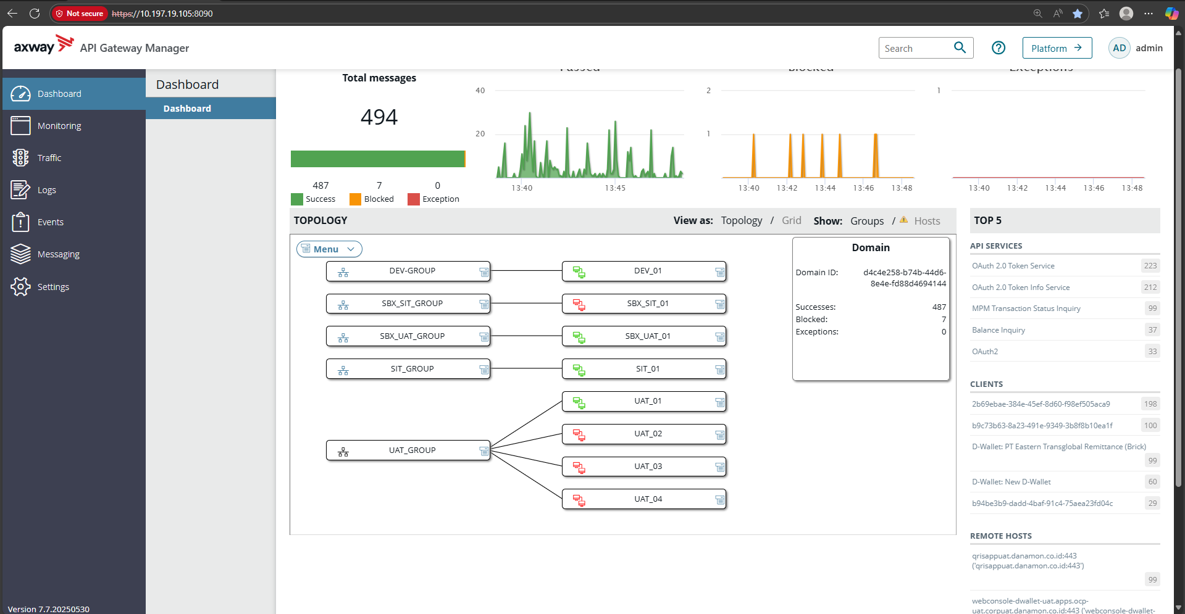

UAT_01

SIT_01

DEV_01

SBX_UAT_01

API PORTAL External

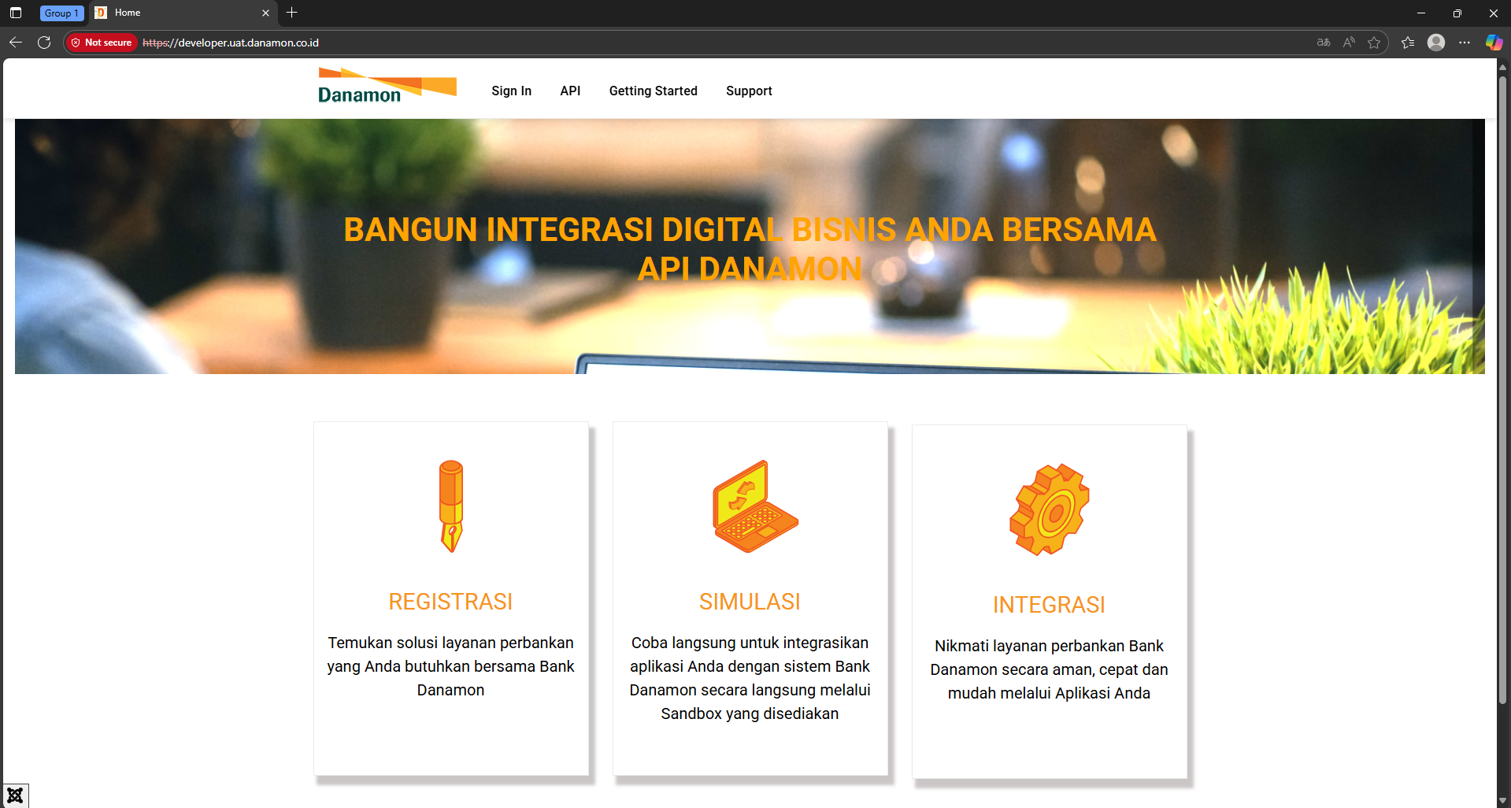

## UAT Internal

APIM Internal

Cassandra 1, 2, 3

API Analytic SIT, UAT External

API Gateway Manager

UAT_01

SIT_01

DEV_01

